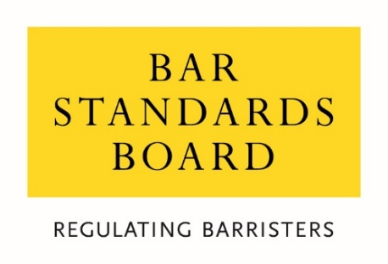
Waiver criteria and guidelines for Criminal Record Checks for Inns’ student members applying for Call in 2026
Introduction
Some international students, or those currently practising overseas who are looking to transfer to the Bar of England and Wales, may be unable to comply with the identification (ID) requirements necessary for the criminal record checks to be undertaken prior to their Call to the Bar ceremony.
The BSB, therefore, is providing a waiver from the requirement to have criminal record checks undertaken for candidates for Call to the Bar in certain circumstances. This waiver does not remove the requirement for candidates for Call to disclose relevant criminal records found on the Call Declaration.
Who is eligible to receive the waiver?
Inns’ student members (including transferring qualified lawyers) who are currently residing overseas with no plans to travel (or return) to the UK prior to their chosen Call ceremony may, using the form provided, discuss with their Inn whether they are eligible under the provisions of this waiver.
This waiver has been introduced specifically for any student member applying for Call in 2026. It will also apply for those who may need to resit exams later in 2026 or in 2027 (for use up to and including Hilary Call 2027), should they not be able to comply with identification requirements closer to these dates. For the avoidance of doubt, this waiver will not apply to students or transferring qualified lawyers taking first sits in 2027.
To whom will the waiver apply?
Any eligible student or transferring qualified lawyer may have the criminal record check requirements waived if either or both of the following criteria apply to their circumstances:
- it is unlawful for them to send the original ID documentation from the country where they are residing; and/or
- sending their original ID documents would represent a threat to their personal safety or freedom.
How will an Inn decide if the waiver applies?
If a person thinks that they are eligible and that the criteria above apply to them, they should complete and return the attached form to their Inn via email.
It is critical that persons do not apply for this waiver unless the criteria set out above apply to their circumstances.
Requests for review of a decision relating to this waiver
If a person is unhappy with the decision taken by their Inn relating to this waiver, the right to review is unaffected and the BSB independent review panel will meet to consider this.

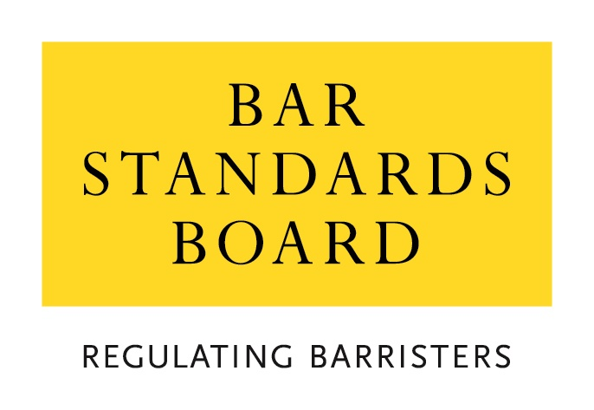

WAIVER CRITERIA AND GUIDELINES FOR CRIMINAL RECORD CHECKS FOR THOSE APPLYING FOR CALL IN 2026

Before completing and submitting this form, you must read the accompanying criteria and guidelines document in full.

This form should be submitted by email to your Inn. You can find the relevant contact details here: CalltotheBar@middletemple.org.uk

Those who are due to be Called to the Bar in July should submit their applications immediately so as to give their Inn as much time as possible to process the request prior to Call. Those due to be Called later in the year should submit their applications as quickly as they are able.

If a waiver is not granted those applying will not be able to be Called until they complete the necessary criminal record checks.

Please ensure that you have submitted all necessary supporting evidence with the application form, as any failure to do so may result in delays in dealing with the application. You may be asked to supply further information or documentation in support of your application. If you refuse to provide the required evidence, your application may be rejected.

This form must be completed in type or BLOCK CAPITALS.

Title (delete as appropriate) | Miss / Mr / Mrs / Ms / Other
First name
Other names
Family name (surname)
Inn Membership Number
MyBar Number
Current Address
Contact phone number (including country code)
Email address
Date of birth

I am currently studying on a vocational component Bar Course | ☐ Yes ☐ No
Academic year (e.g. 2020-21)
Institution
Full-time / part-time | ☐ full-time ☐ part-time

Do you intend to practice at the Bar of England and Wales?

WAIVER REASON
Please tick one or both of the following boxes to indicate why you are applying for a waiver:
☐ It is unlawful for me to send the original ID documentation from the country where I am residing.
☐ Sending my original ID documents would represent a threat to my personal safety or freedom.

INFORMATION SUPPORTNG YOUR APPLICATION
Please set out below why you are applying for this waiver. You may also want to supply any further information (or evidence) that you consider to be relevant to your application.
Eg. information from a government website setting out the reasons why it is not possible for you to send your documentation to the UK.

DECLARATION
I declare that:
- I am currently residing outside the UK and have no plans to travel (or return) to the UK prior to my chosen Call ceremony;
- I have read the waiver criteria and guidelines;
- The information I have given in this application is complete and true;
- Any supporting evidence that I have supplied with this application that refers to third parties has been suitably redacted so as to preserve the anonymity of third parties;
- I am submitting this application with the intention of obtaining a waiver from the requirement to have DBS checks undertaken, normally as part of my Inn’s Call to the Bar procedure and;
- I have read my Inn’s Privacy Statement and the Bar Standards Board’s Privacy Statement and understand how my data will be handled.
Signature
Name
Date

Persons should only disclose matters which would not otherwise be ‘filtered’. If you are unsure what you should disclose, please speak with your Inn. For more information, please see our information for applicants here.
https://www.barstandardsboard.org.uk/privacy-statement.html

