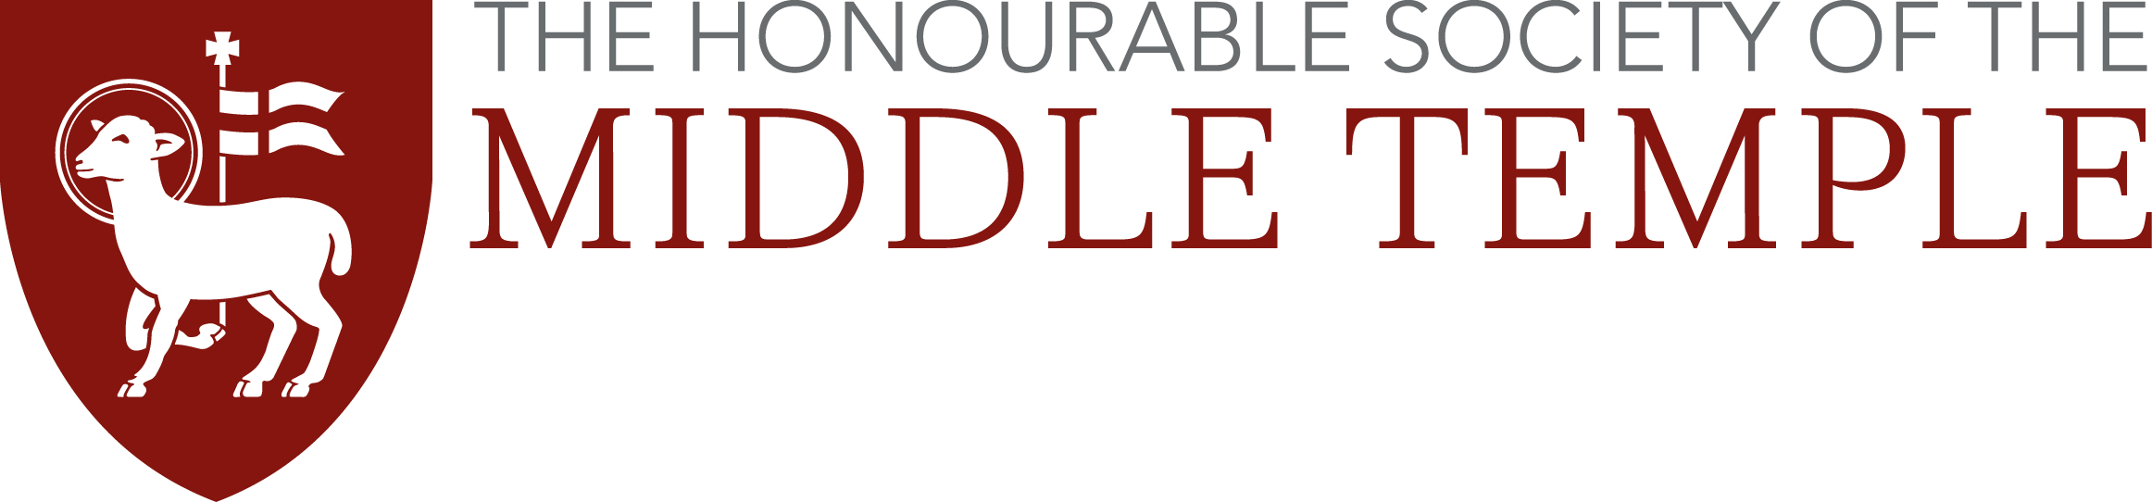
Rosamund Smith Mooting Competition
Travel Expenses Claim Form

The Inn will reimburse travel expenses (up to £75 maximum) if you need to make a journey to the Inn (from outside the M25) specifically to participate in a moot.

Please note: the Inn will only pay for your transport into and out of London. We will not cover the cost of tube, bus or taxi journeys in and around London.

Those travelling by car will be reimbursed at the level of the cheapest train fare from their point of departure. You are asked to find out the cost of such a train fare and indicate accordingly on this form.

PLEASE PROVIDE YOUR RECEIPT/TICKET FOR TRAVEL WITH THIS FORM
Failure to produce a receipt or ticket may mean non-payment of your expenses.

Reimbursements will be paid by direct bank transfer into your account.

Membership No:
Full Name:
Current address:
BPTC/GDL Institution:
Moot Date:
Rail Fare: |  | Departure Point:
Coach Fare: |  | Departure Point:
SORT CODE: |  | ACCOUNT NO:

Please complete this form and return it with a receipt or train ticket to:
Moot Travel Expenses
Middle Temple Treasury
Ashley Building
London
EC4Y 9BT

Or return via email: g.brown@middletemple.org.uk

