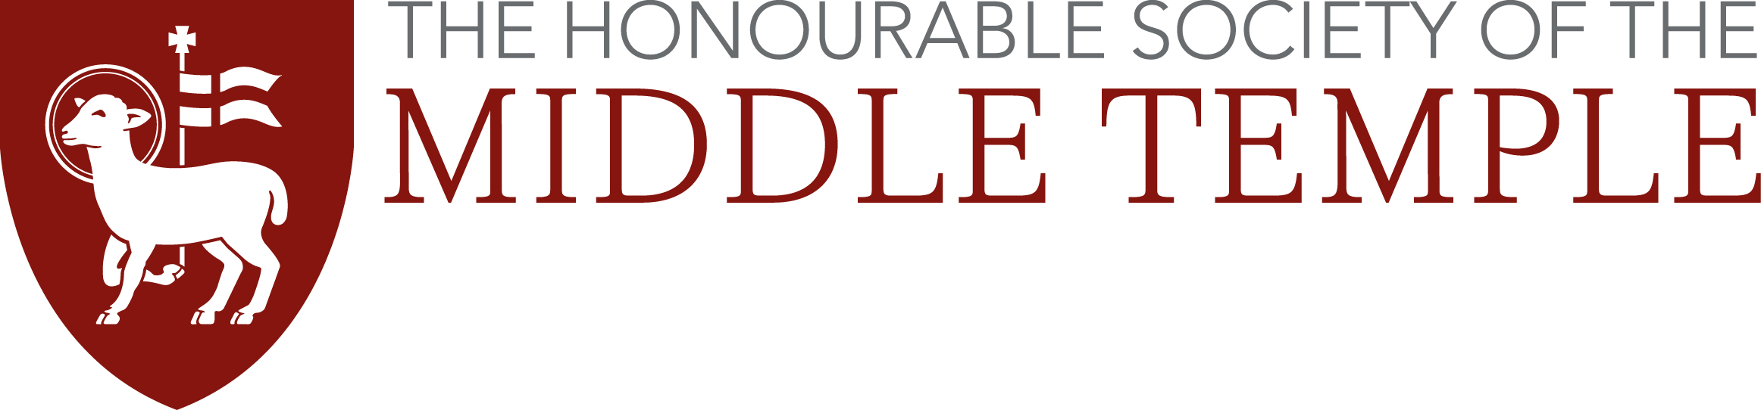
Rosamund Smith Mooting Competition
Travel Expenses Claim Form

As a student studying the BPTC/GDL outside of London, the Inn will cover the cost of your transport to and from London for each of your moots during the competition. We prefer to pay by direct bank transfer into your account.

Those travelling by car will be reimbursed at the level of the cheapest train fare from their point of departure. You are asked to find out the cost of such a train fare and indicate accordingly on this form.

Membership No:
Full Name:
Moot Date:
BPTC/GDL Institution:
Rail Fare: |  | Departure Point:
Coach Fare: |  | Departure Point:
SORT CODE: |  | ACCOUNT NO:
Please note: the Inn will only pay for your transport into and out of London. We will not cover the cost of tube, bus or taxi journeys in and around London. You can claim up to £65.

PLEASE RETAIN YOUR TICKET FOR TRAVEL AND ATTACH IT TO THIS FORM
Failure to produce a receipt or ticket may mean non-payment of your expenses.

Please complete this form and return it with a receipt or train ticket to:
Moot Travel Expenses
Middle Temple Treasury
Ashley Building
London
EC4Y 9BT

Or return via email: g.brown@middletemple.org.uk

