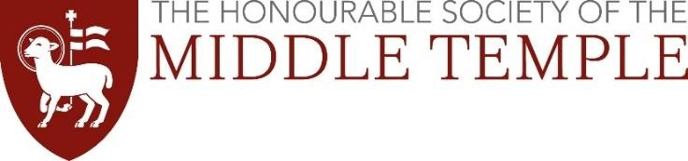
SCHOLARSHIP INTERVIEWS 2026 TRAVEL EXPENSES CLAIM FORM

Middle Temple is prepared to reimburse your reasonable travel expenses to attend your interview, up to a maximum of £75 per candidate. Reimbursement will only be permitted to candidates travelling from outside the M25 (and does not include travel within London, e.g. bus/tube/taxi).

Travel expenses will be paid by BACS transfer into your bank account – please provide details below. If you do not have a UK bank account, please email the address below.

Travelling by train or coach
Please complete this form and attach your ticket and/or receipt.

Travelling by car
Those travelling by car will be reimbursed at the level of a students’ rate coach fare from their point of departure. Please find out the cost of such a coach fare and provide evidence of this together with this form (i.e. a screen shot from coach website).
Disabled students travelling by car will be reimbursed at the rate of 90p per mile. Please complete the form and include the number of miles travelled.

Please complete this form clearly, in BLOCK CAPITALS
Name:  Telephone Number:  Email Address:  Date of interview:  Method of travel:  Departure point:  Cost of return journey:  Bank Details:  Account Number:  Sort Code:  Bank Name: | ________________________________________  ________________________________________  ________________________________________  ___ / ___ / ___  TRAIN / COACH / CAR (delete as appropriate)  ________________________________________  £ ______  ________________________________________

This form (and any receipts) should be returned to: scholarshipapplications@middletemple.org.uk within 7 days of your interview. Claims made after this time will not be processed.

