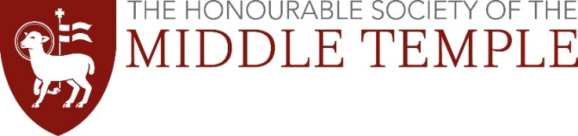
Scholarship Interviews 2024
Travel Expense Claim Form

Middle Temple is prepared to reimburse your reasonable travel expenses to attend your interview, up to a maximum of £75 per candidate. Reimbursement will only be permitted to candidates travelling from outside the M25 (and does not include travel within London, e.g. bus/tube/taxi).

Travel expenses will be paid by BACS transfer into your bank account – please provide details below. If you do not have a UK bank account please email the address below.

Travelling by train or coach
Please complete this form and attach your ticket and/or receipt.

Travelling by car
Those travelling by car will be reimbursed at the level of a students’ rate coach fare from their point of departure. Please find out the cost of such a coach fare and provide evidence of this together with this form (i.e. a screen shot from coach website).
Disabled students travelling by car will be reimbursed at the rate of 90p per mile. Please complete the form and include the number of miles travelled.

Please complete this form clearly, in BLOCK CAPITALS

Name: ________________________________________
Telephone Number: ________________________________________
Email Address: ________________________________________
Date of interview: ___ / ___ / ___
Method of travel: TRAIN / COACH / CAR (delete as appropriate)
Departure point: ________________________________________
Cost of return journey: £ ______
Bank Details:
Account Number: ________________________________________
Sort Code: ________________________________________
Bank Name: ________________________________________
This form (and any receipts) should be returned to: scholarshipapplications@middletemple.org.uk within 7 days of your interview. Claims made after this time will not be processed.

