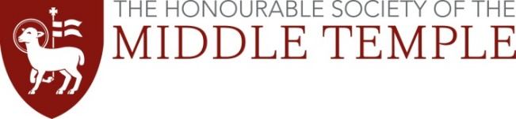
Lloyd Jacob Memorial Award 2024

This prize is provided by a charity called the Knights of the Round Table. It is awarded to students or other junior members of the Inn who have made a special contribution to the Inn's work for its students or junior members.

The prize entails an award of £2500 which will be presented at a dinner on 19 March 2024. At that event, the winner will be expected to make a brief presentation or give a small performance after dinner, focusing on an Arthurian theme, together with the recipient of an equivalent award who is a member of Inner Temple.

Name:
MT Membership number:
Bar Course provider:
Course dates:
Email address:

Please describe below in no more than 300 words how you have contributed to the Inn’s work for its students or junior members.

