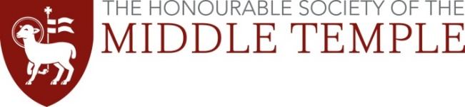
Colombos Essay Prize 2021

‘“The ILC Articles on State Responsibility are the Napoleonic Code of international law.” Discuss.

Name:
MT Membership number:
Address:
Postcode:
Email address:

Word Count*:
*The limit is 3,000 words. The word count does not include footnotes, but footnotes should be used for pure reference purposes and should not include analysis

Declaration
By signing this document I confirm that;
- I have read and understood the guidance on plagiarism and consequent penalties, which is available on the Middle Temple website.
- the essay I am submitting for the Colombos Essay Competition is my sole creation and original work. Any work from other authors is acknowledged and appropriately referenced.
- I am a member of the Middle Temple, and am either a student, or a newly Called barrister looking for, or currently undertaking, pupillage.
- I intend to practise at the Bar of England and Wales.

Signed:
Date:

