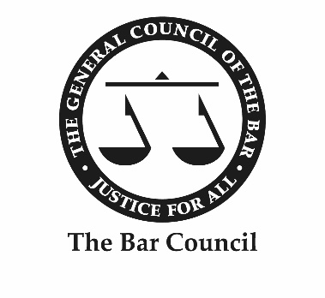

Annual General Meeting of the Bar 2019

To be held on Saturday 7 September 2019 at 11:00 in the Old Hall, Lincoln’s Inn, WC2A 3TL

Notes:
1. Except for the proposer of a resolution who may speak for seven minutes, no subscriber shall be entitled without the consent of the Chair of the meeting to speak more than once or for more than five minutes on the same subject.
2. Only subscribers are entitled to vote.
3. A proxy vote requires notice to the Chief Executive of at least 24 hours prior to the meeting of due medical or religious grounds preventing attendance at the meeting and must be cast by either a nominated representative at the meeting or the Chair of the meeting.

1. Chair’s Address

Report from Richard Atkins QC

2. Treasurer’s Report, including Annual Report and Accounts

Report from Grant Warnsby

3. Chief Executive’s Report

Report from Malcolm Cree

