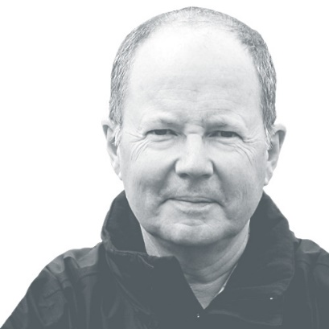
James Thornton

Chief Executive Officer

James Thornton is the founding CEO of ClientEarth. The New Statesman has named him as one of 10 people who could change the world. The Lawyer has picked him as one of the top 100 lawyers in the UK. In 2016, he was named as one of the 1,000 most influential people in London and also won Leader of the Year at the Business Green Awards. The Financial Times awarded him its Special Achievement accolade at the FT 2016 Innovative Lawyers Awards.
He is an environmental lawyer and social entrepreneur. A member of the bars of New York, California and the Supreme Court of the United States, and a solicitor of England and Wales, he moved from Wall Street law practice to found the Citizens’ Enforcement Project at NRDC in New York, where he brought some 80 federal lawsuits against corporations to enforce the Clean Water Act after the Reagan Administration had stopped enforcing the law. He won these cases and embarrassed the government to start enforcing the law again.
James founded ClientEarth – Europe’s first public interest environmental law organisation – in 2007. Now operating globally, it uses advocacy, litigation and research to address the greatest challenges of our time – including biodiversity loss, climate change, and toxic chemicals. Its work is always built on solid law and science. In 2017, James co-authored a book with his husband Martin Goodman, telling the fascinating story of ClientEarth since it was founded. The book won the judges category in the Business Book of the Year Award in 2018.
Previously James lived in Los Angeles where he founded the Los Angeles Office of NRDC, which does internationally important environmental work with the support of the Hollywood community. He was Editor in Chief of the New York University Law Review, where he later served as Adjunct Associate Professor of Environmental Law. He has also been an executive in several other sectors of the non-profit world.
He graduated from Yale, Phi Beta Kappa, magna cum laude, with departmental honours in philosophy. He is the author of an environmental legal thriller, Immediate Harm, and volume of poetry on science and environment, The Feynman Challenge. He is a Conservation Fellow of the Zoological Society of London; and a fellow of the Ashoka Foundation.

