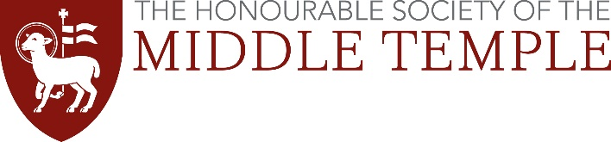
Certified Copies Guidance

Degree certificates
For any completed degrees we require a certified copy of the degree certificate.

Who can certify a document
Option 1: Your document must be certified by a professional person or someone well-respected in your community (‘of good standing’). You could ask the following if they offer this service:
- bank or building society official
- councillor
- minister of religion
- dentist
- chartered accountant
- solicitor or notary
- teacher or lecturer

The person you ask must not be:
- related to you
- living at the same address
- in a relationship with you

Option 2: The Post Office also offer a document certification service.

Option 3: You can bring your documents to the Inn in person and we will take copies and certify them for you. You must not send your original certificates by post as we will not be responsible for its safe return to you.

How to certify a document
Take a photocopy of your certificate and then take the copy and the original and ask the person to certify the copy by:

- writing ‘Certified to be a true copy of the original seen by me’ on the document
- signing and dating it
- printing their name under the signature
- adding their occupation, address and telephone number. Alternatively, this information can be added using a stamp

The person certifying the document may charge you a fee.

