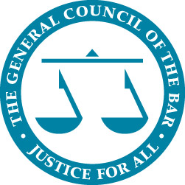 | 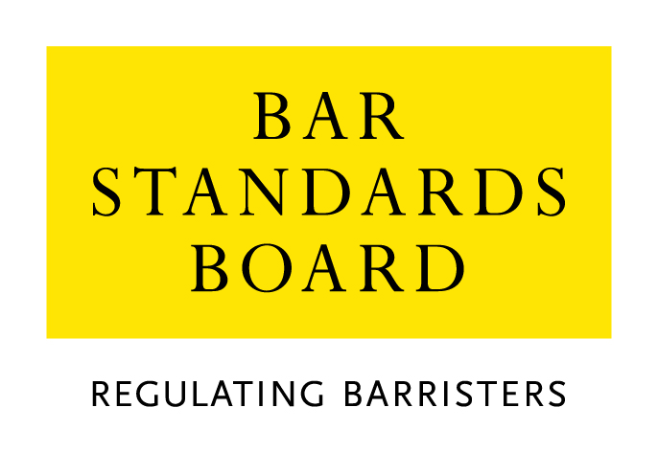

Equality & Diversity Monitoring form

Diversity data gathered from this form will be anonymised and used to inform Bar Council and Bar Standards Board (BSB) policy aimed at widening access to the profession and improving diversity. It will assist the Bar Council and BSB in meeting our statutory duties under the Equality Act 2010 and will inform our wider equality and diversity strategy.

Your diversity data will be treated as confidential and stored securely according to the Bar Council’s Privacy policy. It will not be published in a way which might identify any individual. The raw data will be kept only for monitoring purposes. Question formats are based on LSB approved monitoring questions. Provision of diversity information is not compulsory however we strongly encourage you to help us by completing this form.

Please answer each question with one option only, unless otherwise indicated. If you do not wish to answer the question please choose the option ‘Prefer not to say’ rather than leaving the question blank.

1. Age
From the list of age bands below, please indicate the category that includes your current age in years:

16 - 24
25 - 34
35 - 44
45 - 54 | x
55 - 64
65+
Prefer not to say

2. Gender
What is your gender?

Male
Female | x
Prefer not to say

3. Disability

The Equality Act 2010 generally defines a disabled person as someone who has a mental or physical impairment that has a substantial and long-term adverse effect on the person’s ability to carry out normal day-to-day activities.

(a) Do you consider yourself to have a disability according to the definition in the Equality Act?

Yes
No | x
Prefer not to say

(b) Are your day-to-day activities limited because of a health problem or disability which has lasted, or is expected to last, at least 12 months?

Yes, limited a lot
Yes, limited a little
No | x
Prefer not to say

4. Ethnic group

What is your ethnic group?

Asian/Asian British

Bangladeshi
Chinese
Indian
Pakistani
Any other Asian background (write in)

Black/African/Caribbean/Black British

African
Caribbean
Any other Black / Caribbean / Black British (write in)

Mixed / multiple ethnic groups

White and Asian
White and Black African
White and Black Caribbean
White and Chinese
Any other Mixed/multiple ethnic background (write in)

White

British / English / Welsh / Northern Irish / Scottish | x
Irish
Gypsy or Irish traveller
Any other White background (write in)

Other ethnic group

Arab
Any other ethnic group (write in)

Prefer not to say

Prefer not to say

5. Religion or belief

What is your religion or belief?

No religion or belief | x
Buddhist
Christian (all denominations)
Hindu
Jewish
Muslim
Sikh
Any other religion (write in)
Prefer not to say

6. Sexual orientation

What is your sexual orientation?

Bisexual
Gay man
Gay woman/lesbian
Heterosexual/straight | x
Other
Prefer not to say

7. Socio-economic background

(a) If you went to University (to study a BA, BSc course or higher), were you part of the first generation of your family to do so?

Yes
No | x
Did not attend University
Prefer not to say

(b) Did you mainly attend a state or fee paying school between the ages 11 – 18?

UK state school | x
UK Independent/fee-paying school
Attended school outside the UK
Prefer not to say

8. Caring responsibilities

(a) Are you a primary carer for a child or children under 18?

Yes | x
No
Prefer not to say

(b) Do you look after, or give any help or support to family members, friends, neighbours or others because of either:
- Long-term physical or mental ill-health / disability
- Problems related to old age?

(Do not count anything you do as part of your paid employment)

No
Yes, 1 - 19 hours a week | x
Yes, 20 - 49 hours a week
Yes, 50 or more hours a week
Prefer not to say

If you have any concerns about this data collection exercise, please contact Sam Mercer, Head of Equality & Diversity Bar Council (SMercer@BarCouncil.org.uk)

